**THE BATTLE OF THE NEIGHBORHOODS**

**IN AUSTIN, TEXAS**

**Applied Data Science Capstone Project by IBM/Coursera**

**TABLE OF CONTENTS**

1. Introduction
2. Data Acquisition and Cleaning
   1. Data Sources
   2. Data Acquisition and Cleaning
3. Methodology
   1. Foursquare
   2. Distance
4. Analysis and Discussion
5. Conclusion

**INTRODUCTION**

**Description and Background**

In this project, we'll explore a Korean fried chicken and bar business opportunity around Austin, Texas neighborhoods. Fried chicken and bar has a very wide appeal in Korea, among all age groups but is particularly popular among the young college students. Korean fried chicken and bar restaurants are also very popular in places like Los Angeles and San Jose where there are large Korean communities.

We'll explore many of the Austin downtown surrounding neighborhoods for the location of the business. Contrary to finding a location away from other food establishments, we'll look to setup the business in a neighborhood where there is a concentration of restaurants.

Opportunity: Korean Fried Chicken and Bar

Location: A neighborhood near Austin, Texas

Target Audience: Korean community but we believe it will have a mass appeal to all age groups and non-Koreans.

**DATA**

**Data, Sources and Methods**

A list of neighborhoods in Austin, Texas will be obtained from wikipedia and the data will be cleaned up and processed through geocode/Nominatim to extract latitudes and longitudes of each neighborhood.

Next the data will be processed through the Foursquare API to obtain venues around the neighborhoods. We'll analyze the resulting data to look for the neighborhood with the highest concentration of fast food/restaurant/fried chicken/bar type businesses as the location choice.

We'll also obtain and analyze data on population size, growth and demographics in Austin for additional support of the business opportunity thesis.

**Data Sources:**

1. Data from wikipedia / Neighborhoods around Austin Texas: https://en.wikipedia.org/wiki/List_of_Austin_neighborhoods

2. World Population Review:

http://worldpopulationreview.com/us-cities/austin-population/

3. Austin Asian Chamber of Commerce:

http://www.austinasianchamber.org/asian-data

4. Data USA: Austin, TX:

https://datausa.io/profile/geo/austin-tx/

**Data Acquisition and Cleaning:**

A list of neighborhoods near Austin, Texas was obtained from Wikipedia.com (https://en.wikipedia.org/wiki/List_of_Austin_neighborhoods). The data was preprocessed for the following:

* Neighborhoods that were too distant from Downtown Austin were dropped.
* Neighborhoods that had missing latitude and longitude information after processing geocode/Nominatim were also dropped.
* Resulting latitude and longitude data series were merged to the revised neighborhood dataframe.

**List of neighborhoods before cleanup:**

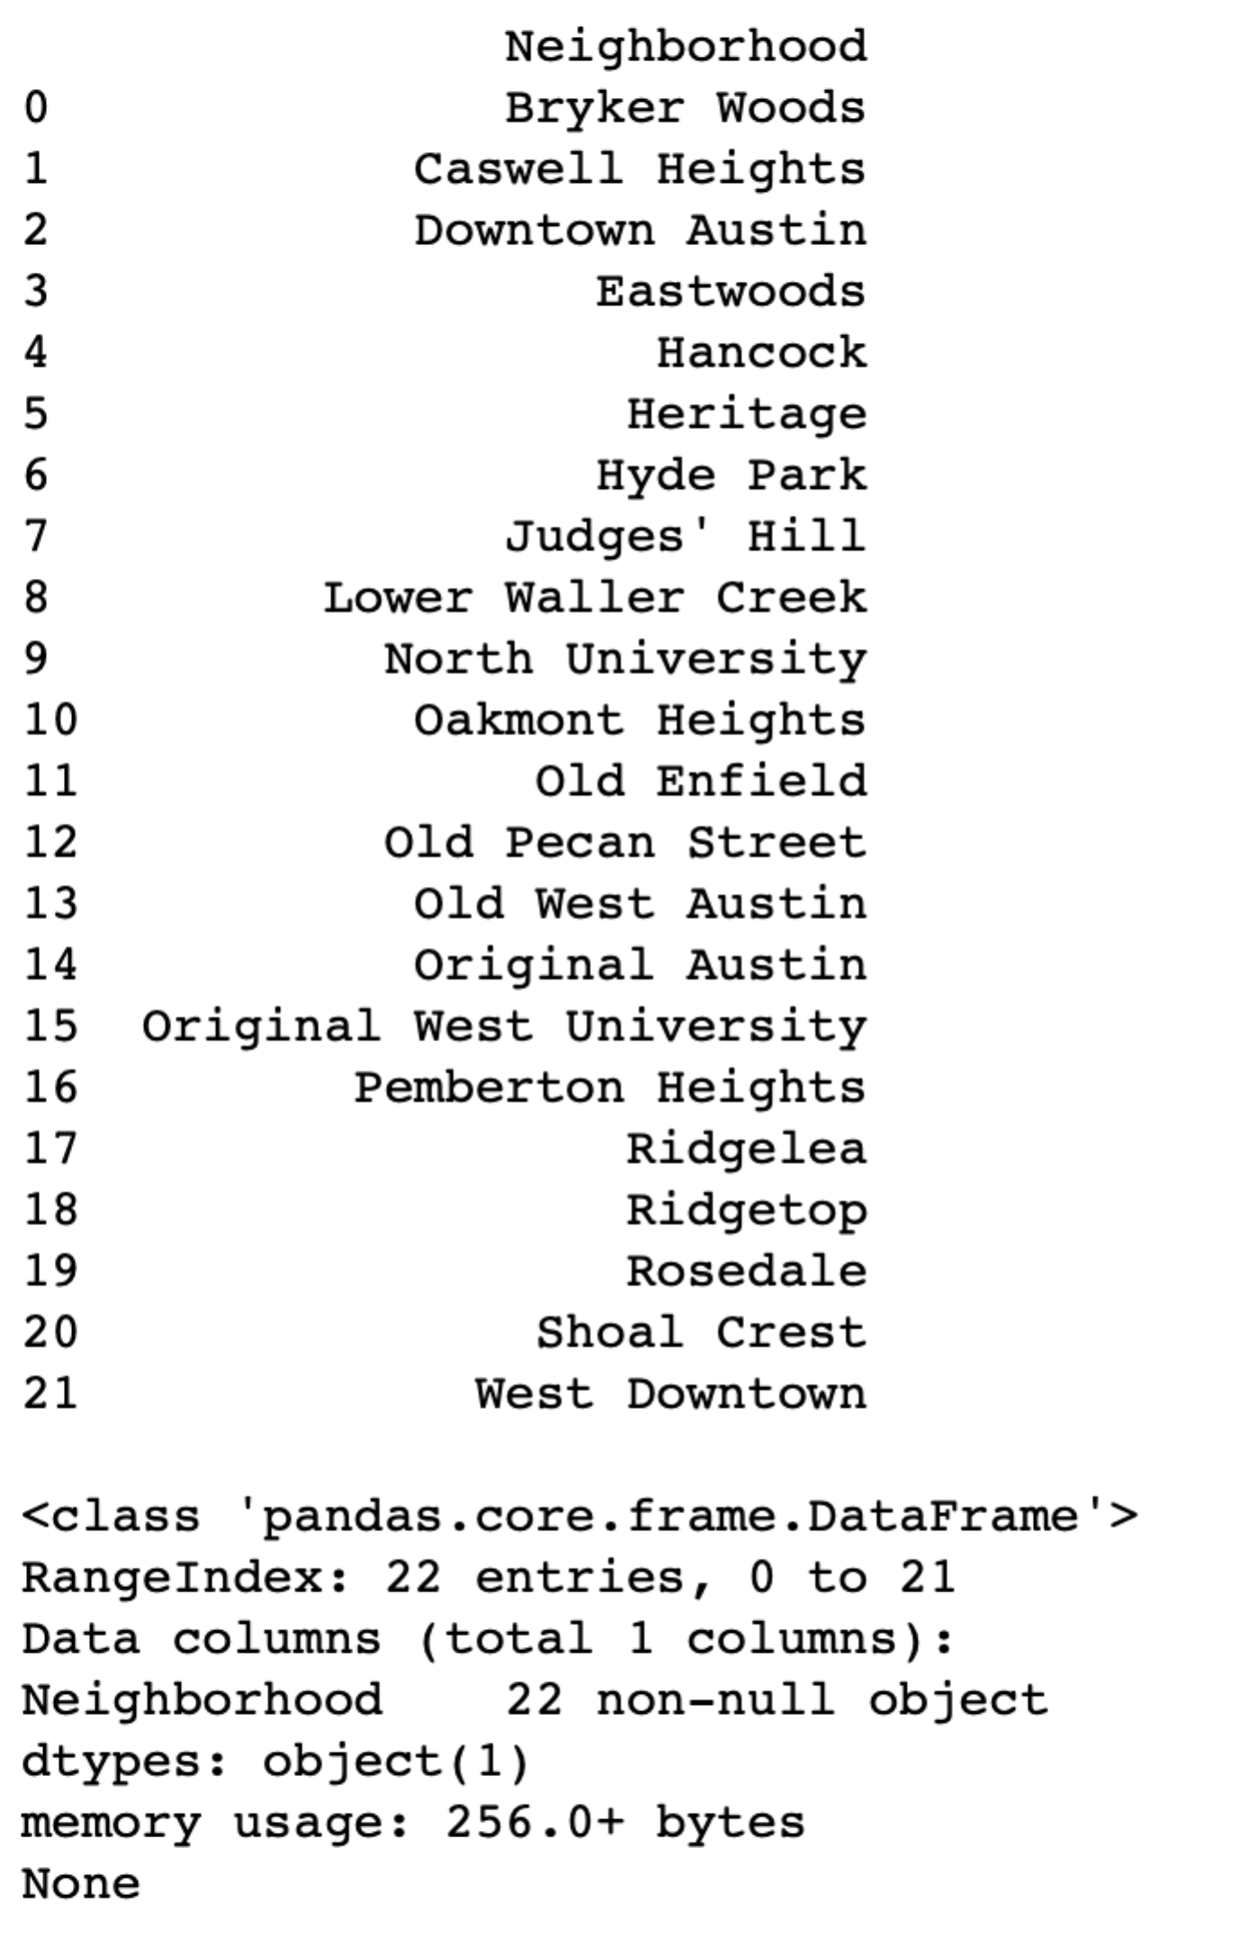

**List of Austin neighborhoods ready for Foursquare processing.**

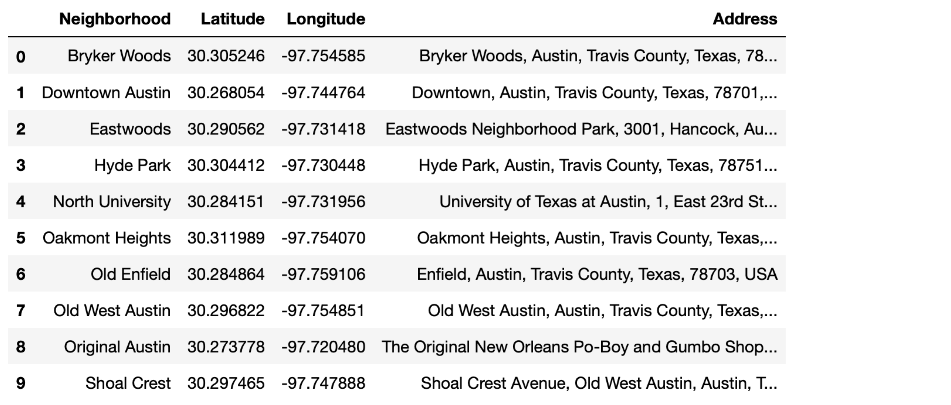

**Map of Neighborhoods in Austin, Texas with Folium:**

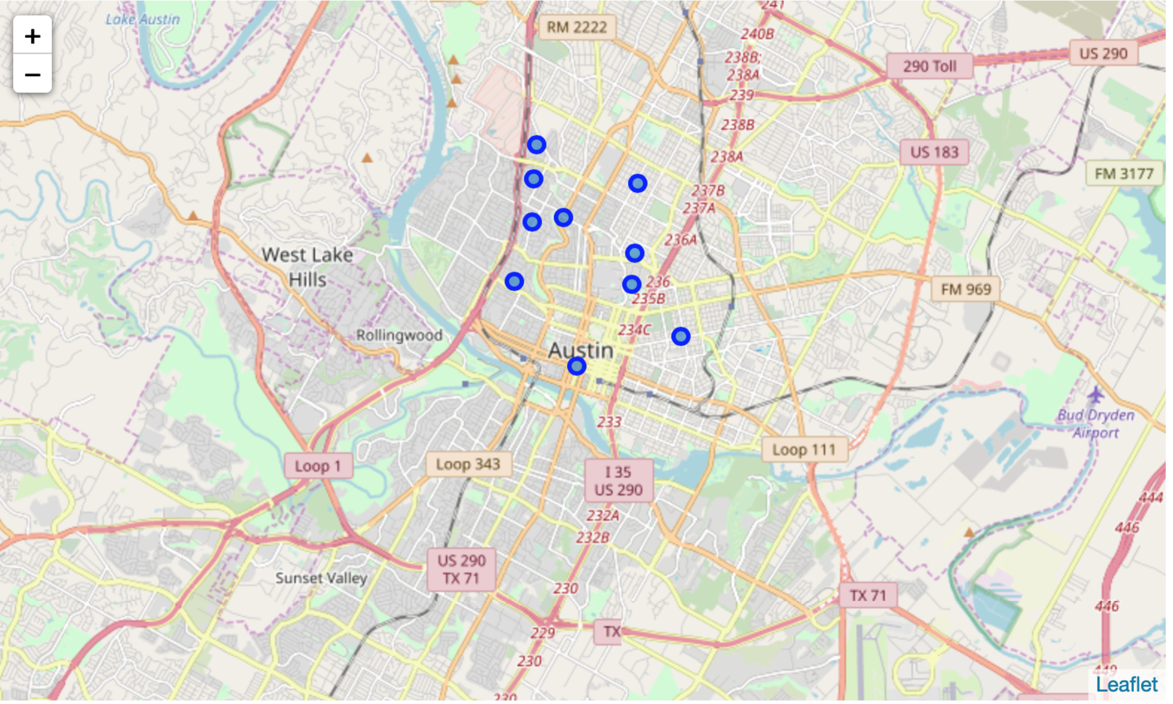

Now that the neighborhood data has been cleaned and processed through Folium and the neighborhoods mapped for visualization, we can move to the next step of finding venues around these neighborhoods for further analysis.

**METHODOOLOGY**

**FOURSQUARE**

Clean data were processed through Foursquare API with starting location of   
Downtown Austin.

**Foursquare processing and venues output:**

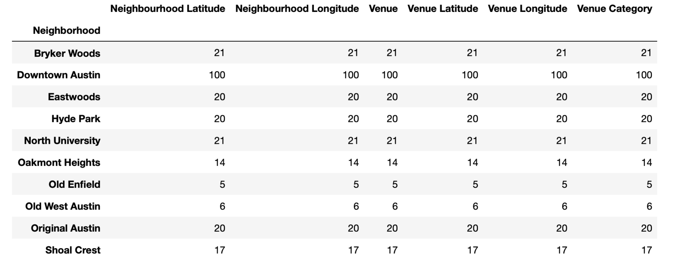

We processed several k values manually and determined that k=6 was a good value to use and move forward for further investigation.

**Map of Neighborhoods Clusters from Foursquare Results**

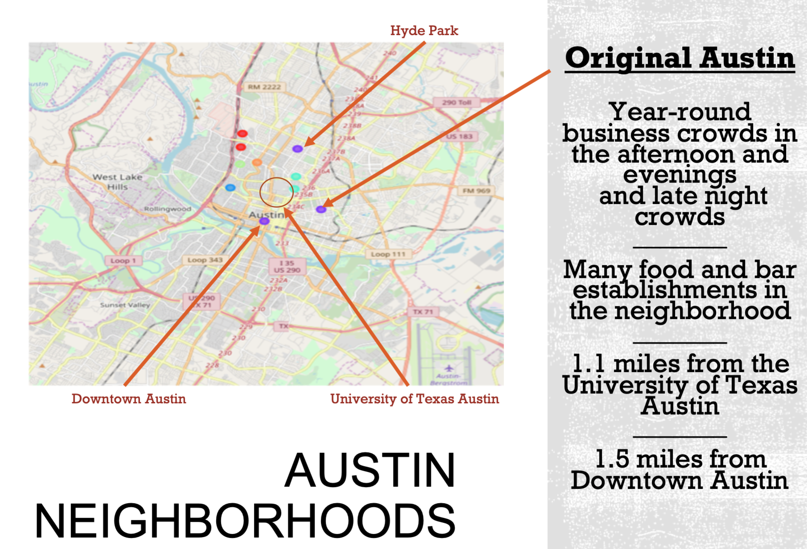

Cluster 1 was chosen to have the best results showing the highest concentration of food and bar type establishments.

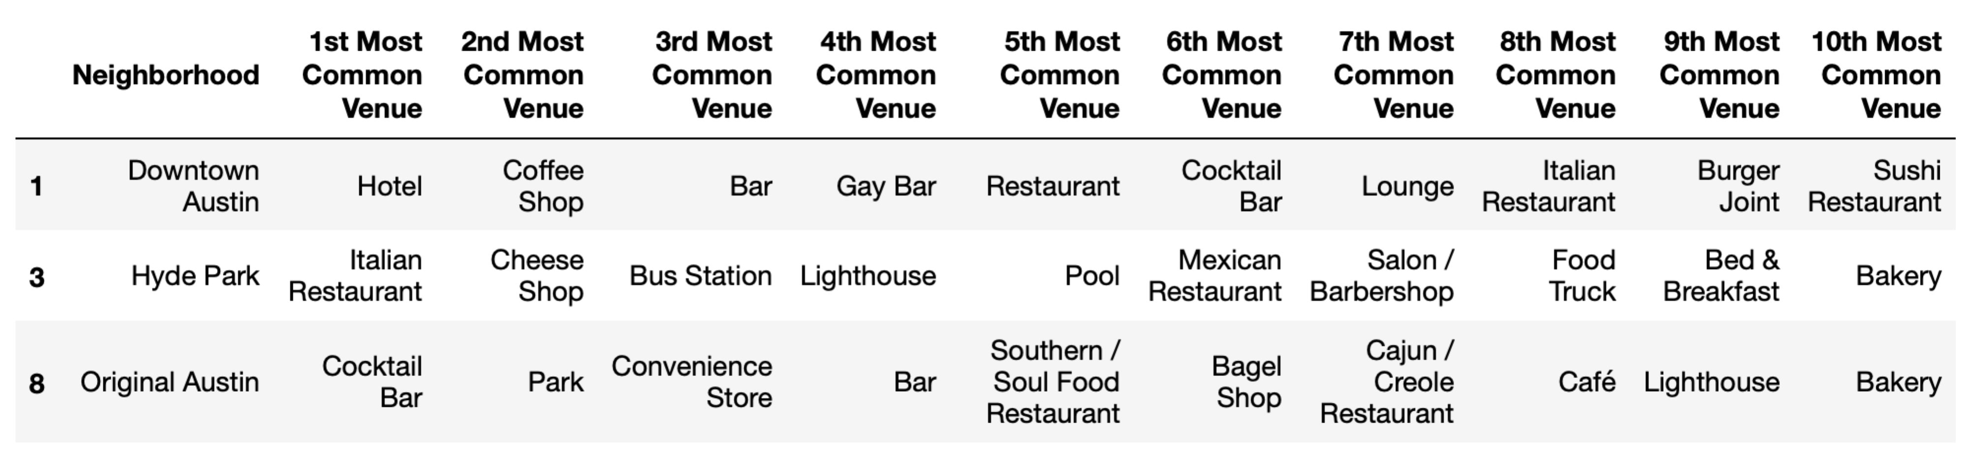

**DISTANCES AMONG SELECTED NEIGHBORHOODS**

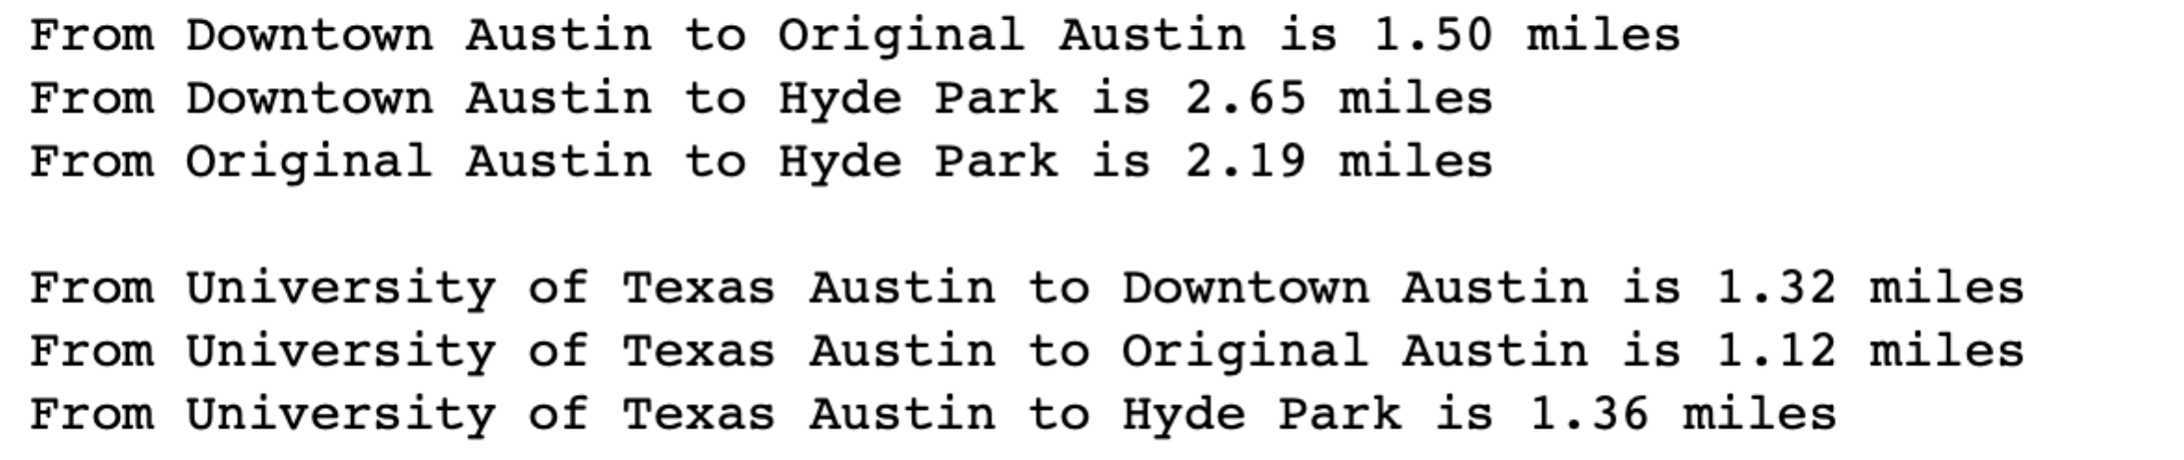

Distances among Downtown Austin, University of Texas Austin, Original Austin and Hyde Park are pretty close to each other. However, the combination of distances among the Downtown Austin, Original Austin and the University of Texas Austin seem to be the best set.

From these three combinations, we think Original Austin is the preferred choice given that it shows the shortest distance from UTA.

**ANALYSIS**

**Original Austin**

* Under 1.0 miles walking distance from the North University

* Ample food and bar establishments as top searches in Foursquare

* Probably lower rent cost than Austin Downtown

* 1.5 miles from Downtown Austin, close enough to attract downtown after work crowds

**Austin Downtown**

* Austin Downtown has many food related venues and bars. This would also be a great choice

* Downtown business after work crowd

* Year-round downtown business crowd

**Population and Demographics in Austin, Texas:**

* Total population in Austin is reaching 1.0 million and growing at 3.0% per year in 2019

* About 10% of Austin population are Asians which represents about 100K people

* About 10% of Asian population in Austin are Koreans which represents 10K people.

* Whites 45%+

* Hispanics 30%+

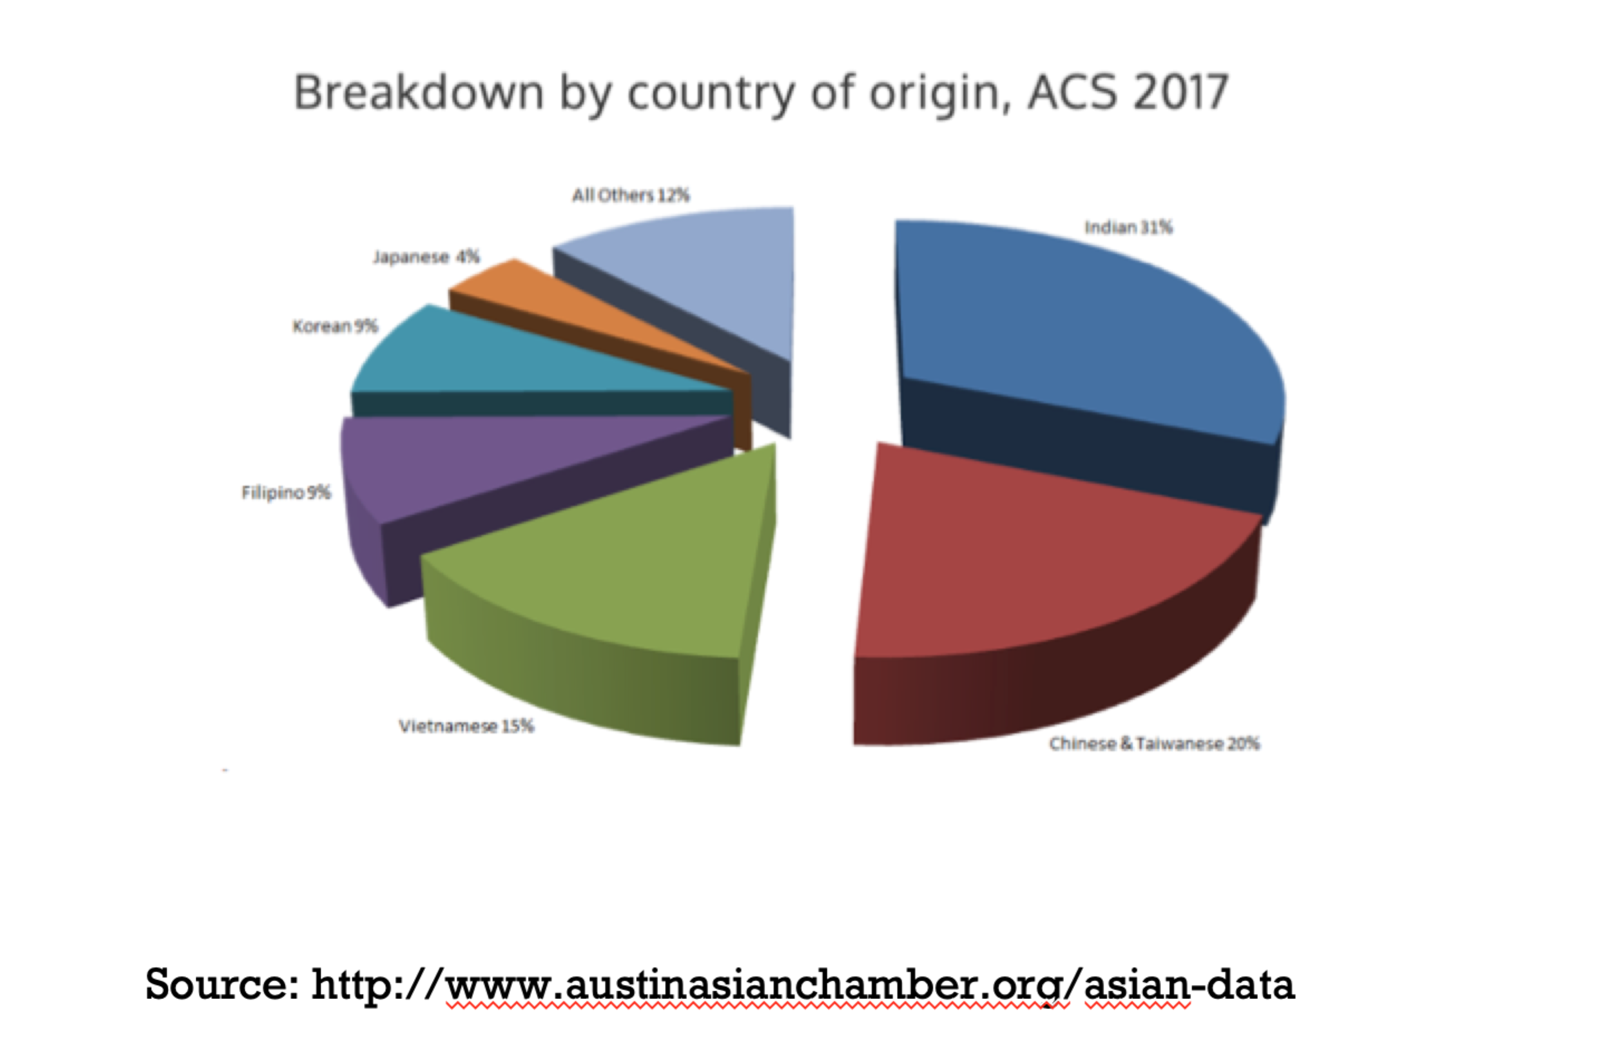

Data source: www.datausa.io

**CONCLUSION**

Original Austin seems to be the ideal neighborhood with its high concentration of food and bar businesses already established.

Original Austin is close to Downtown Austin (1.5 miles) and the University of Texas Austin (1.1 mile) to attract crowds from these adjacent neighborhoods.

Austin offers a growing community, with population reaching 1.0 million in 2019, with annual growth rate of 3.0%, and relatively young crowd with median age of 33.

The Korean population in Austin is about 9K, which should generate ample demand. Assume, nominally, another 1% conversion of total Austin population and the potential customer base grows to ~20K which is a very sizable opportunity.

As mentioned on the onset of this project, Korean fried chicken and bar is very popular in Korea, among all age groups from college students and up. It is also very popular in Los Angeles and San Jose where there are large Korean communities and very diverse ethnicities and we believe it will be very popular in Austin as well.

Combining all the data collected and analyzed, Original Austin neighborhood, Austin population growth and demographics data, all support a good foundation to start the Korean fried chicken and bar business in Austin, Texas.

Next phase of the business case would be to actually build the Korean fried chicken and bar design, style, menu, services, size, financials, etc. All of these are beyond the scope of this project.